**Automatic Door Open System With Visitor Counter**

**Using ARDUINO UNO**

**Introduction:**

You must have seen automatic door openers in shopping malls and other commercial buildings. They open the door when someone comes near the entrance and close it after sometime or when he or she go away from the doors sensor range. A number of technologies are available to make such kinds of systems like PIR sensors, Radar sensors, Laser sensors, Infrared sensors, etc. in this arduino based project, we have tried to replicate the same system using PIR sensor.

It uses a motion-detecting sensor (PIR sensor) to open or close the door which detects the infrared energy which emitted from human’s body. When someone comes in front of the door, the infrared energy detected by the sensor changes and it triggers the sensor to open the door whenever someone approaches the door. The signal is further sent to the **arduino uno** that controls the door.

**Components:**

* Arduino UNO
* PIR Sensor
* Motor driver
* Connecting wires
* Bread board
* 1 k resistor
* Power supply
* 6x2 LCD

**Circuit Diagram:**

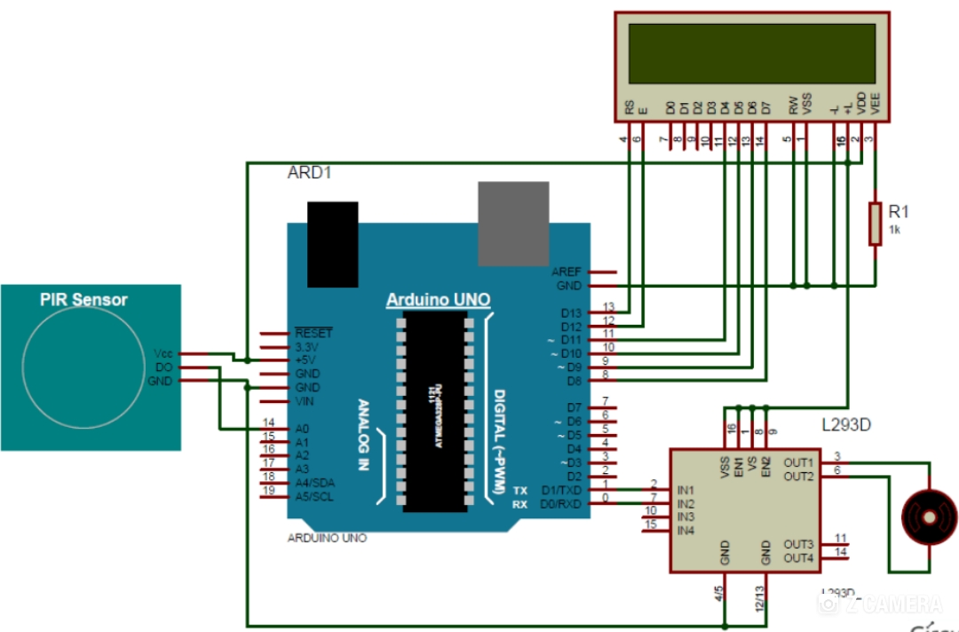

**PIR Sensor:**

PIR sensor detects any change in heat, and whenever it detects any change, its output PIN becomes HIGH. They are also referred as Pyroelectric or IR motion sensors.

Here we should note that every object emits some amount of infrared when heated. Human also emits infrared because of body heat. PIR sensors can detect small amount of variation in infrared. Whenever an object passes through the sensor range, it produces infrared because of the friction between air and object, and get caught by the PIR sensor.

**Program:**

#include  
LiquidCrystal lcd(13, 12, 11, 10, 9, 8);  
#define PIR_sensor 14  
#define m11 0  
#define m12  
void setup()  
{lcd.begin(20, 4);  
lcd.clear ();  
pinMode(m11, OUTPUT);  
pinMode(m12, OUTPUT);  
pinMode(PIR_sensor, INPUT);  
lcd.print("INTELLEGENT DOOR");  
lcd.setCursor(0,1);  
lcd.print("ELECTRONIFY.ORG");  
delay(1000);  
}  
void loop()

{  
if(digitalRead(PIR_sensor))  
{  
lcd.setCursor(0,2);  
lcd.print("Movement Detected");  
lcd.setCursor(0, 3);  
lcd.print(" Gate Opened ");  
digitalWrite(m11, HIGH);

digitalWrite(m12, LOW);  
delay(1000);  
digitalWrite(m11, LOW);   
digitalWrite(m12, LOW);  
delay(1000);  
lcd.setCursor(0, 3);  
lcd.print(" Gate Closed ");  
digitalWrite(m11, LOW);   
digitalWrite(m12, HIGH);  
delay(1000);  
digitalWrite(m11, LOW);   
digitalWrite(m12, LOW);  
delay(1000);}

else  
{

lcd.setCursor(0,2);  
lcd.print(" No Movement ");  
lcd.setCursor(0,3);  
lcd.print(" Gate Closed ");  
digitalWrite(m11, LOW);  
digitalWrite(m12, LOW);  
}  
}

**Motor Driver:**

The most common method to drive DC motors under control of a computer is with a H-bridge motor driver. And we use the integrated circuit(ic) L293D.

**L293D Motor Driving Module**

The integrated circuit (ic) L293D is used to control the direction of rotation of motor. This device is just used upto 600mA current in theoretical way but for practical use, we have to use it below then the current limitations to work our experiment efficiently.

**Diagram**



**Features:**

* Easily compatible with any of the system
* Easy interfacing through FRC (Flat Ribbon Cable)
* External power supply pin for motors supported
* Onboard PWM selection switch
* 2 pin terminal block for easy motors connection
* Onboard H-bridge base motor driver IC (L293D)

**Specifications:**

* Power Supply :
* Over FRC connector 5V DC
* External Power 9V to 24
* Temperature Range is 0°C to 70 °C

**IC 293D:**

The driver IC L293D is quad push-pull drivers capable of delivering output currents to 1A per channel respectively. Each channel is controlled by a TTL-compatible logic input and each pair of drivers is equipped with an inhibit input available at pin 1 and pin 9. The motor will run only when chip inhibit is at logic ” high”.

**Diagram:** 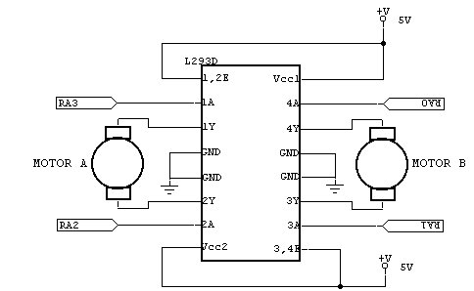

We can save on Arduino pins by connecting the Enable pin to +5V and using just the two direction pins to change directions and turn the motor on and off. Put one pin high and the other low for one direction, reverse the state of the pins for the other direction and put both pins low to turn the motor off.

The L293D have automatically thermal stoppage system which means it will be automatically off if it gets too hot.

**Applications:**